Drafting Note: Pursuant to the Minnesota Wage Theft Prevention Act, as amended by Minnesota’s Earned Sick and Safe Time law, this document should be provided to an employee prior to the date the change of any of the below bullets take effect. Other than ESST information, which must be provided to an employee on or before January 1, 2024, the information below regarding wage theft, need only be included if it is being changed. So, for example, if the employee is receiving a pay raise, and nothing else is changing, only the new pay rate needs to be included. Or, if the employee is only having a change to their sick time, pursuant to the ESST law, then that is what would be on this form.

[Date]

[Employee Name]
[Employee Address]
[Employee City, State ZIP]

Dear [Employee Name]:

Beginning on [date the below change(s) will take effect], the following changes to the terms and conditions of your employment will take effect:

- Your rate of pay will now be $[xxxx] per hour/week/year.
- You will now be a [part-time/full-time (choose one)] employee. You are now [exempt/not exempt (choose one)] from minimum wage, overtime, and other provisions of chapter 177 of the Minnesota Statutes. [If now classified as an exempt employee, add: Your position is now exempt under the [Executive/Professional/Administrative/Computer Employee/Outside Sales/Highly Compensated Employee (choose one)] exemption.]
- [Articulate changes to PTO/Vacation/Sick Leave entitlements, if changing].

[FOR CHANGES TO PAID TIME OFF ENTITLEMENTS THAT RESULTED FROM ESST, YOU CAN INCLUDE THE FOLLOWING: Employees in Minnesota are entitled to paid sick and safe time. You will receive sick time as follows [Insert information regarding how earned sick and safe time/PTO is earned (frontloading/accrual) including the rate at which it is frontloaded/accrued, and any information regarding carryover/payout].

The Company measures a “year” as the 12-month period [beginning January 1 and ending December 31/beginning on the employee’s first day of employment (note: here is where you define the accrual or benefit year for the employee. Examples include the calendar year, year by work anniversary or another 12-month period.)]

The [PTO/earned sick and safe time] hours you have available, as well as those that have been used in the most recent pay period, will be indicated on your earnings statement that you receive at the end of each pay period. [Earned sick and safe time/PTO used for earned sick and safe time-covered reasons] will be paid at the same hourly rate you earn from employment. You are not required to seek or find a replacement for your shift to use [earned sick and safe time/PTO used for earned sick and safe time-covered reasons]. You may use [earned sick and safe time/PTO used for earned sick and safe time-covered reasons] for all or part of a shift, depending on your need. [Earned sick and safe time/PTO] can be used for:

- Your mental or physical illness, treatment or preventive care;
- The mental or physical illness, treatment or preventive care of your family member;
- Absence due to domestic abuse, sexual assault or stalking of you or your family member;
- Closure of your workplace due to weather or public emergency or closure of your family member’s school or care facility due to weather or public emergency; and
- When determined by a health authority or health care professional that you or your family member is at risk of infecting others with a communicable disease.

The Company can require you to provide up to seven days of advance notice when possible (for example, when you have a medical appointment scheduled in advance) before using [earned sick and safe time/PTO]. The Company can also require you to provide certain documentation regarding the reason for your use of [earned sick and safe time/PTO for an earned sick and safe time-covered reason] if you use it for more than three consecutive days.

[Include information regarding how employees can provide notice to the Company of their use of earned sick and safe time/PTO for earned-sick and safe time-covered reasons. For example: If an employee plans to use earned sick and safe time for an appointment, preventive care or another permissible reason they know of in advance, inform [name or position] by [phone, email or other communication] as far in advance as possible, but at least [number between one and seven] days in advance. In situations where an employee cannot provide advance notice, the employee should contact [name or position] at [phone, email or other communication] as soon as they know they will be unable to work.] Additional information regarding the terms of use of [earned sick and safe time/PTO] can be found in our Employee Handbook.

It is against the law for the Company to retaliate, or to take negative action, against you for using or requesting earned sick and safe time or otherwise exercising their earned sick and safe time rights under the law. If you believe you have been retaliated against or improperly denied earned sick and safe time, you can file a complaint with the Minnesota Department of Labor and Industry. You can also file a civil action in court for earned sick and safe time violations. For more information, contact the Minnesota Department of Labor and Industry’s Labor Standards Division at 651-284-5075 or dli.laborstandards@state.mn.us or visit the department’s earned sick and safe time webpage at dli.mn.gov/sick-leave.

- The following deductions [will/will no longer (choose one)] be made from your pay:
  - [List any changes to deductions here, if any]
- The number of days in the pay period will be [xx].
- Your regularly schedule pay days will be [dates of new pay days].
- Our [legal name/operating name (choose one or both as applicable)] is now __________.
- Our physical address is now ___________________.
- Our phone number is now ___________________.

You are receiving this written change notice in accordance with Minnesota Statutes Section 181.032(f) [if communicating changes as a result of ESST, add: and Minnesota Statutes Section 181.9447, subd. 9]. This notice is provided to you in English. Nothing in this notice is intended as, nor should it be construed as, an employment contract for a definite or indefinite period of time. You are and will remain an at-will employee while working with us. If you have any questions, or if you need this form translated in a particular language, please contact _______________________ at [phone number or email].

Sincerely,

[Name]
[Title]

cc: Personnel File

Acknowledgment of Receipt of Written Change Notice

Drafting Note: Including an acknowledgment of receipt is optional for change notices.

By signing below, I acknowledge I have received the foregoing written change notice provided in accordance with Minnesota Statutes Section 181.032(f) [if communicating changes as a result of ESST, add: and Minnesota Statutes Section 181.9447, subd. 9].

[Name] Date

This document contains important information about your employment. Check the box at left to receive
this information in this language.
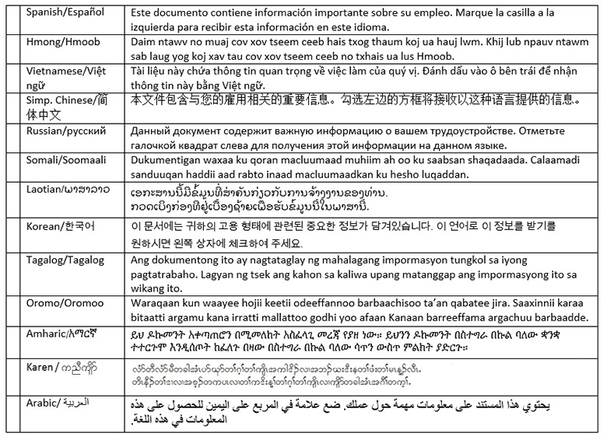Translation providers approved by the Minnesota Department of Administration
Betmar Languages, Inc.  6260 Hwy. 65 N.E.  Minneapolis, MN 55432  763-572-9711  best@betmar.com | The Bridge World Language Center, Inc.  110 Second Street S., #308  Waite Park, MN 56387  320-259-9239  mini@bridgelanguage.com | Fox Translation Services  1152 Mae Street, #122  Hummelstown, PA 17033  866-369-1646 or 407-733-3720  dina@foxfoxcasemanagement.com
Global Translation and Interpreter  913 E. Franklin Ave., #206  Minneapolis, MN 55404  612-722-1244  sandor@globaltranslations.com | Latin American Translators Network, Inc.  1720 Peachtree Street N.W., #532  Atlanta, GA 30309  800-943-5286, ext. 8641, translations@latn.com  800-943-5286, ext. 8620, idenis@latn.com | Latitude Prime, LLC  80 S. Eighth Street, #900  Minneapolis, MN 55402  888-341-9080, ext. 501  elle@latitude.com
Lingualinx Language Solutions, Inc.  433 River Street, #6001  Troy, NY 12180  518-388-9000  abartlett@lingualinx.com | Prisma International, Inc.  1128 Harmon Place, #310  Minneapolis, MN 55403  612-349-3111  jromano@prisma.com | Swits, LTD  110 S. Third Street  Delavan, WI 53115  262-740-2590  translations@swits.us

Please note that the information provided is only accurate as of the day posted (December 12, 2023). The information provided does not, and is not intended to, constitute legal advice; instead, all information is prepared and provided for general informational purposes only.
Copyright © 2023 Roe Law Group, PLLC, All rights reserved.

